RF Propagation & Trajectory Studio

User Manual and Documentation

1 Introduction
RF Propagation & Trajectory Studio is an interactive MATLAB application for wireless coverage prediction, trajectory simulation, and dataset generation. The integrated GUI (app.m) bundles scenario setup, transmitter/receiver management, coverage visualization, directional antenna design, RRT-based trajectory generation, vehicle kinematics simulation, transformer-based trajectory synthesis, and automated dataset export into a single App Designer interface.Visualizing RF Signal Coverage is made to streamline analyzing RF signal propagation and the creation of signal maps. With the assistance of this application, users may assess and display signal strength, coverage regions, and signal dispersion throughout a target area.

1.1 Overview of the application
The project's main goal is to streamline the creation of heatmaps for signal transmission and the analysis of signal propagation in diverse contexts. This program enables academics, engineers, and anyone else interested in signal propagation analysis to get insights into signal intensity, coverage, and dispersion through the provision of an intuitive user interface and strong computing capabilities.
The project offers a thorough and user-friendly framework for signal propagation analysis, enabling users to learn important details about signal strength and coverage regions in various settings. This program makes it easier to examine signal propagation and produce instructive signal maps for RF signal tracking algorithm training and testing, whether for research, engineering, or instructional applications.
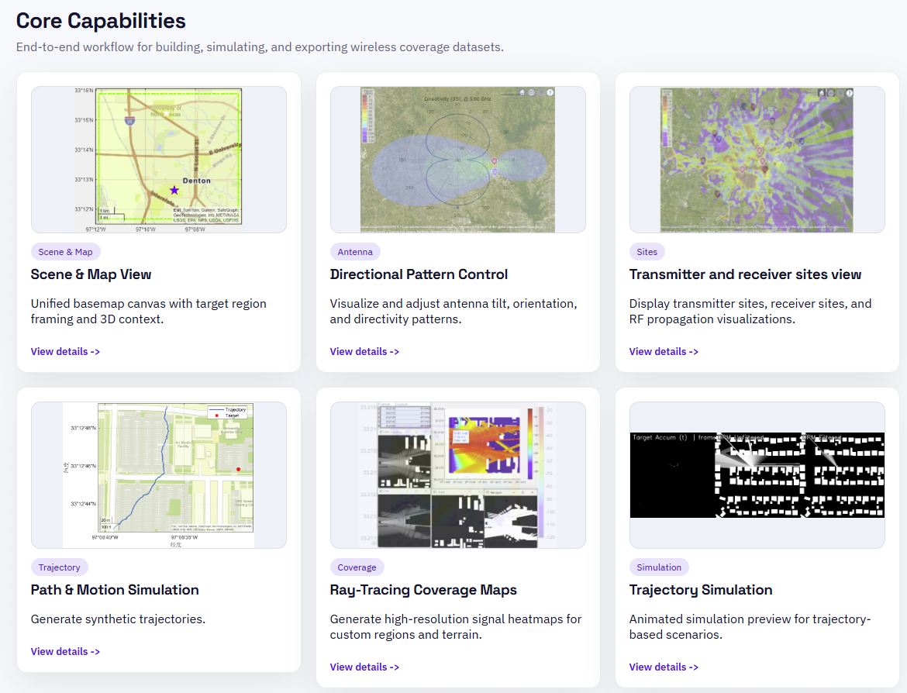
Figure: Core Capabilities of RF Propagation & Trajectory Studio

1.2 Purpose and Objectives
The project aims to provide a robust and user-friendly MATLAB program for the signal propagation analysis and the signal map creation. By providing an easy-to-use interface, comprising a number of practical functions, the program seeks to make the process of assessing signal strength, coverage regions, and signal dispersion across a given territory more straightforward.
The main objectives are:
Simplify Signal Propagation Analysis:
Offer consumers an easy-to-use, interactive platform to examine signal propagation in various situations.
Give users the option to choose target areas and choose multiple propagation models to simulate various environmental circumstances.
Display the target areas on an interactive map to make the study of signal coverage easier to grasp.
Facilitate Transmitter and Receiver Placement:
Allow users to manually enter or upload a CSV file to establish the locations and specifications of transmitters and receivers.
Give users access to tools for calculating the appropriate coverage area for the specified transmitters, receivers, and geographic location.
By defining the tilt angle and tilt axis for transmitters, make it possible for users to investigate directional antenna layouts.
Generate Informative Signal Maps:
Provide the option to create random locations within the target area depending on predetermined criteria, such as the quantity of transmitters, the size of the grid, the types of distribution, the frequency, and the power.
Offer visualization choices for each transmitter and receiver's specific coverage zones, taking into account obstructions like buildings.
Produce heatmaps that show the signal distribution and coverage across the specified grid, enabling users to understand how the signal varies over the area.
Enable Dataset Generation and Export:
Provide users with the option to save the power distribution and heatmap data as CSV files for later analysis and documentation.
Give users a simple-to-use interface to designate the dataset's output route for downloading, making it simple to maintain and have access to the data that has been created.
By achieving these goals, the project hopes to equip researchers, engineers, and anyone else interested in signal propagation analysis with the tools necessary to quickly analyze and visualize signal strength, coverage areas, and distribution, and assist them to make well-informed decisions and optimize a variety of signal-dependent applications.

1.3 Target Audience
The project is intended to serve a broad spectrum of experts and researchers engaged in the study of wireless communication networks and signal propagation. The following audience is the target of the application:
Telecommunication Engineers and Researchers:
Telecommunication professionals who are involved in designing and optimizing wireless communication networks.
Researchers working on signal propagation analysis, antenna modeling, and coverage optimization.
Wireless Network Planners and Operators:
Network planners responsible for assessing signal coverage, capacity, and quality in wireless networks.
Operators who need to optimize their network performance and troubleshoot signal coverage issues.
IoT (Internet of Things) Application Developers:
Developers working on IoT applications that rely on wireless connectivity and require accurate signal strength analysis.
Professionals involved in deploying IoT devices and systems in various environments. 4) Academic Researchers and Students:
Researchers and students in the field of wireless communications, network engineering, and signal processing.
Those who require a comprehensive and user-friendly tool for conducting experiments, simulations, and data analysis.
5) Signal Analysis and RF Engineers:
Engineers involved in analyzing and troubleshooting signal strength, interference, and noise in wireless systems.
RF (Radio Frequency) engineers working on antenna design, characterization, and performance evaluation.

2 Installation and Setup

2.1 System requirement
Ensure that your system meets the minimum requirements:
Operating System: Window 10 or more
MATLAB R2025 or later with the following toolboxes: Antenna Toolbox, Communications Toolbox, Phased Array System Toolbox, Mapping Toolbox, Navigation Toolbox, Signal Processing Toolbox

2.2 Installation Instructions

2.2.1 MATLAB Installation:
If you haven't already, install MATLAB by following the instructions provided by MathWorks on their website.
Make sure to activate your MATLAB license.

2.2.2 Downloading the project Application:
Go to the project repository on GitHub.
Click on the "Download" button or clone the repository to your local machine.

2.2.3 Extracting the Files:
a) If you downloaded a ZIP file, extract its contents to a preferred location on your computer.

2.2.4 Launching the Application:
Open MATLAB on your computer.
Navigate to the extracted project folder using the MATLAB file browser.

2.2.5 Running the Application:
In the MATLAB file browser, locate the latest application entry file:
"app.m" is the main integrated application entry point. It exposes the full feature set including coverage analysis, trajectory generation, and dataset export.
Run app.m from MATLAB to launch the integrated GUI. Type "app" in the MATLAB Command Window and press Enter.

3 Getting Started

3.1 Interface overview
Users of the program may engage with a variety of features and capabilities. The various panels and components that make up the application interface are described in general in this section.

3.1.1 Environmental Properties Panel:
Users can choose the propagation model for the environment and specify the target region in this window.
Users can enter the latitude and longitude for the target region's north-east and south-west corners on the "Target Region" page.
The "Propagation Model" tab offers a variety of models (such as rain, fog, and free space) for replicating the propagation properties of the environment.

3.1.2 Target Region:
The "Target Region" tab in the Environmental Properties panel allows users to define the specific geographic area of interest for their analysis. By specifying the north-east and south-west coordinates, users can define a rectangular region on the map that represents their target area. Once the target region is defined, it is automatically highlighted on the map panel, providing users with a visual confirmation of the selected area. This visual representation helps users ensure that they have accurately defined the desired geographic region for their analysis. The "Target Region" tab empowers users to focus their analysis on specific geographical areas of interest, enabling them to gain valuable insights into signal propagation and coverage within the defined region.

3.1.3 Map Panel:
The Map panel, which is placed next to the Environmental Properties panel, shows a picture of the target area.
Users can alter the map's glance by choosing a base map from a dropdown menu.
The Environmental Properties panel’s target region will be highlighted on the map.

3.1.4 Swarm Properties Tab:
Users can specify the features of transmitters and receivers using this tab in the third panel.
You may manually enter transmitter and receiver configuration information in the "Transmitter and Receiver Configuration" panel or upload a CSV file with the data.
Both additional transmitters and receivers will be shown on the map panel next to the target area.
Based on the specified transmitters and receivers, the "Plot Ideal Coverage" button creates the optimum coverage area. It assesses if receivers are within range and graphically indicates the coverage region.

3.1.5 Directional Antenna Panel:
This panel, which can be found under the Swarm Properties page, allows users to see directivity patterns using directional antennas.
To see the coverage regions depending on the directivity pattern of the transmitters and receivers, users can set the tilt angle and tilt axis.

3.1.6 Signal Map Generation Tab:
The dataset generation for the creation of signal maps is the sole focus of this tab.
Users enter the target area, the quantity of transmitters, the grid size (n and m), the kind of distribution (for example, linear), the frequency, and the power of the transmitter.
The "Generate Random Sites" button generates random sites inside the target region using the chosen grid size.
By choosing certain sites from a drop-down menu and pressing the "Visualize Coverage Area" button, users may view specific sites. This shows the coverage area while accounting for impediments like buildings.
Based on the specified grid, the "Generate Heat Map" button creates a heatmap showing the coverage regions.

3.1.7 Data Download:
The dataset for every site may be downloaded using a path that users can choose.
The process of downloading the heat maps and power distribution CSV files for each transmitter site begins when the "Save Files" button is clicked.

4 Environmental Properties Panel
Users can specify the features of the target area and choose the best propagation model for signal analysis using the Environmental Properties tab in the project application. There are two primary tabs on this panel: "Target Region" and "Propagation Model."

4.1 Target Region
Users can define the geographic region of interest where the signal analysis will be carried out on the Target Region tab. By entering the coordinates for the north-east and south-west corners, users may choose the target region. This gives the option of picking a certain area or region for study.
The system uses a mix of the geoaxes(), geoplot(), and geobasemap() methods when the user inputs the coordinates and clicks the "Plot Target Region" button. Figure 1 gives the glimpse when complete target region is plotted in the map panel.
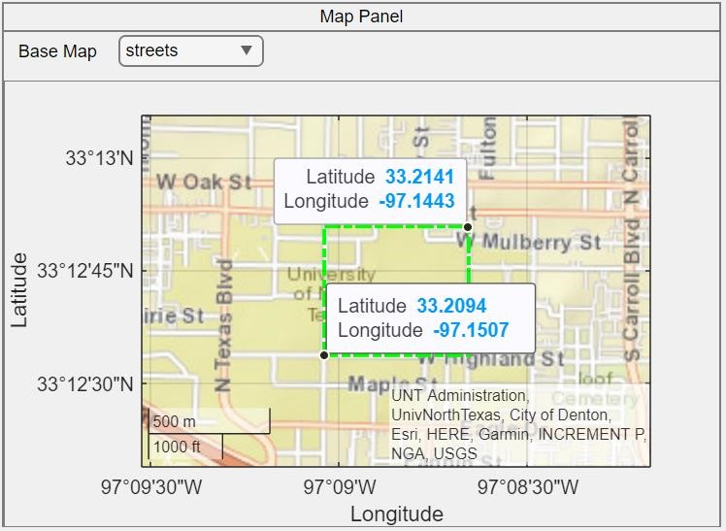
Figure 1 Map Panel for Target Region Visualization

4.1.1 Geoaxes():
Geoaxes creates a geographic axes in the current figure and makes it the active axis using default attribute settings [1].
A geographic axis displays data in geographic coordinates (latitude/longitude) on a map. You may pan the map to view other locations around the world and zoom in and out to view various regions in more detail because it is dynamic [1].

4.1.1.1 Input Argument:

4.1.1.1.1 Parent – Parent container:
Parent container, specified as a Figure, Panel, Tab, TiledChartLayout, or GridLayout object. [1]

4.1.1.1.2 Basemap:
Specified as one of the following values in table 1, the map on which the data will be shown. Natural Earth was used to build the tiled data sets for six of the basemaps. [1] Table 1 Various Basemap Options

4.1.1.1.3 Position:
Size and location, excluding margin for labels, specified as a four-element vector of the form [left bottom width height]. [1]

4.1.1.2 Output

4.1.1.2.1 gx – Geographic Axes
Geographic axes, returned as a GeographicAxes object. [1]

4.1.2 Geoplot()
geoplot(lat,lon) plots a line in geographic coordinates. Specify latitude coordinates in degrees using lat and specify longitude coordinates in degrees using lon. If the current axes is not a geographic or map axes, or if there is no current axes, then the function plots the line in a new geographic axes [2].

4.1.2.1 Input Argument

4.1.2.1.1 Lat
Latitude coordinates in degrees, specified as a vector [2].

4.1.2.1.2 Lon
Longitude coordinates in degrees, specified as a vector [2].

4.1.2.1.3 LineSpec
Line style, marker, and color can all be set as symbols in a character vector or string scalar. Any combination of the symbols may be used. The three properties (line style, marker, and color) do not all need to be specified. For instance, if you supply the marker but omit the line style, the plot will simply display the marker [2].

4.1.2.1.4 LineWidth
A positive number of points, where 1 point is equal to 1/72 of an inch, is used to specify the line width. If the line has markers, the borders of the markers are likewise impacted by the line width [2].

4.1.2.2 Output

4.1.2.2.1 h – Geographic Plot
Geographic plot, returned as a column vector of Line objects. Each object corresponds to a plotted line. Use h to modify the properties of the objects after they are created [2].

4.1.3 Geobasemap()
GeobaseMap Basemap sets the value supplied by basemap for the Basemap attribute for the current geographic axes or geographic bubble chart. The function produces a new geographic axis using the supplied basemap if the existing axes is not a geographic axes or a geographic bubble chart, or if there is no current axes. When using this syntax, the basemap parameter, such as geobasemap topographic, does not need to be enclosed in quotation marks [3].

4.1.3.1 Input Argument

4.1.3.1.1 Basemap – Map on which to plot data
This arguments take anyone value as specified in table 1, as an input, and adjust the glance of the map accordingly [3].

4.1.3.1.2 gx – Target
Target, provided as an object with the following names: GeographicAxes, GeographicBubbleChart, or GeographicGlobe (Mapping Toolbox) [3].
If you don't give this option, the geobasemap method, assuming the current axes are a geographic axes object or a geographic bubble chart, sets the basemap for the current axes.

4.2 Propagation Model
Users may choose from a variety of propagation models on the Propagation Model page to simulate the signal behavior in the chosen target region. Several environmental factors that might affect signal transmission are represented by several propagation models, including rain, fog, freespace, and others [4]. Depending on the traits they wish to imitate, users can select the most suitable model.
Here are the list of propagation models available:
Table 2 Various Propagation Models

The Environmental Properties tab enables users to adapt the signal analysis to their own needs by allowing them to specify the target region and choose the propagation model. The basis for further analysis and visualization of signal coverage and propagation patterns within the target region is provided by these parameters.

5 Swarm Properties
Users may set up and maintain settings for the swarm of transmitters and receivers in the Swarm Properties panel, which is a part of the program. It gives users the ability to specify the locations and properties of the transmitters and receivers, as well as to see their coverage regions and directivity patterns.

5.1 Transmitters and Receivers
There mainly two ways of defining the transmitters and receivers and are listed below.

5.1.1 Manual entry of details
In the swarm properties tab, there further three tabs, two of which are named as Transmitter and Receiver.

5.1.1.1 Transmitter Tab
This tab is dedicated to define the transmitters. The table 3 below give the attributes that are needed to filled for adding the transmitter in application. Furthermore, the added transmitter sites will be highlighted by the white star in map panel on the geoplot.
Table 3 Transmitter Tab Attributes
The data passed through these fields will be treated as argument for the function txsite().

5.1.1.1.1 txsite(): txsite object to create a radio frequency transmitter site [5].

5.1.1.1.1.1 Input Argument:

5.1.1.1.1.1.1 Name – Site Name
Site name, provided as a row or column vector with N items, a character vector or string, or both. When name is specified as a row or column vector, several sites are produced [5].

5.1.1.1.1.1.2 CoordinateSystem – Coordinate system used to site location
'Geographic' or 'Cartesian' coordinate systems are employed to specify the site's location. If you choose the 'geographic' option, the site's location will be determined by its Latitude, Longitude, and AntennaHeight values. The site location is specified using the AntennaPosition property if "cartesian" is used [5].

5.1.1.1.1.1.3 Latitude
Latitude coordinates for the site, either as a numeric scalar in the range [-90, 90] or as a row or column vector of N items. Multiple sites can be created by specifying latitude as a row or column vector. The reference ellipsoid for the World Geodesic System of 1984 (WGS-84) is used to define the coordinates. North-South position is indicated by latitude [5].

5.1.1.1.1.1.4 Longitude
Longitude coordinates for the site, either as a numeric scalar in the [-180 180] range or as a row or column vector of N items in the [-180 180] range. When longitude is specified as a row or column vector, numerous sites are produced. The reference ellipsoid for the World Geodesic System of 1984 (WGS-84) is used to define the coordinates. East-West location is described by longitude [5].

5.1.1.1.1.1.5 Antenna
Antenna element or array with one of the following designations: "isotropic" (the default), "dipole," "monopole," "con," "fractal," "helix," "horn," "loop," "patch," "reflector," "slot," etc.

5.1.1.1.1.1.6 AntennaAngle
Antenna X-axis angle expressed in terms of a local Cartesian coordinate system, provided as a numeric scalar expressing an azimuth angle in degrees, or as a 2-by-1 vector or 2-by-N matrix representing both azimuth and elevation angles with each element unit in degrees [5].

5.1.1.1.1.1.7 AntennaHeight
Height of the antenna above the ground or the surface of a structure, expressed as a nonnegative numeric scalar in meters. The property's maximum value is 6,371,000 m [5].

5.1.1.1.1.1.8 AntennaPosition
The location of the antenna center is given as a 3-by-1 vector with each element indicating the X, Y, and Z axes in meters [5].

5.1.1.1.1.1.9 SystemLoss
Specified as a nonnegative scalar in dB, system loss. Transmission line failures and other sporadic system losses are considered system losses [5].

5.1.1.1.1.1.10 TransmitterFrequency
Transmitter operating frequency, specified as a positive scalar in Hz. in the range [1e3 200e9] [5].

5.1.1.1.1.1.11 TransmitterPower
Signal power at transmitter output, specified as a positive scalar in watts. The transmitter out is connected to the antenna [5].

5.1.1.2 Receiver Tab
This tab helps to define the receivers for the visualization. Below quoted table 4 contains the list of attributes which are needed to fill for adding the new receiver site.
Table 4 Receivers Tab Attributes
The above mentioned values filled in these fields will act as an input for the function rxsite().

5.1.1.2.1 rxsite():
rxsite object to create a radio frequency receiver site [6].

5.1.1.2.1.1 Input Argument:

5.1.1.2.1.1.1 Name – Site Name
Site name, provided as a row or column vector with N items, a character vector or string, or both. When name is specified as a row or column vector, several sites are produced [6].

5.1.1.2.1.1.2 CoordinateSystem – Coordinate system used to site location
'Geographic' or 'Cartesian' coordinate systems are employed to specify the site's location. If you choose the 'geographic' option, the site's location will be determined by its Latitude, Longitude, and AntennaHeight values. The site location is specified using the AntennaPosition property if "cartesian" is used [6].

5.1.1.2.1.1.3 Latitude
Latitude coordinates for the site, either as a numeric scalar in the range [-90, 90] or as a row or column vector of N items. Multiple sites can be created by specifying latitude as a row or column vector. The reference ellipsoid for the World Geodesic System of 1984 (WGS-84) is used to define the coordinates. North-South position is indicated by latitude [6].

5.1.1.2.1.1.4 Longitude
Longitude coordinates for the site, either as a numeric scalar in the [-180 180] range or as a row or column vector of N items in the [-180 180] range. When longitude is specified as a row or column vector, numerous sites are produced. The reference ellipsoid for the World Geodesic System of 1984 (WGS-84) is used to define the coordinates. East-West location is described by longitude [6].

5.1.1.2.1.1.5 Antenna
Antenna element or array with one of the following designations: "isotropic" (the default), "dipole," "monopole," "con," "fractal," "helix," "horn," "loop," "patch," "reflector," "slot," etc.

5.1.1.2.1.1.6 AntennaAngle
Antenna X-axis angle expressed in terms of a local Cartesian coordinate system, provided as a numeric scalar expressing an azimuth angle in degrees, or as a 2-by-1 vector or 2-by-N matrix representing both azimuth and elevation angles with each element unit in degrees [6].

5.1.1.2.1.1.7 AntennaHeight
Height of the antenna above the ground or the surface of a structure, expressed as a nonnegative numeric scalar in meters. The property's maximum value is 6,371,000 m [6].

5.1.1.2.1.1.8 AntennaPosition
The location of the antenna center is given as a 3-by-1 vector with each element indicating the X, Y, and Z axes in meters [6].

5.1.1.2.1.1.9 SystemLoss
Specified as a nonnegative scalar in dB, system loss. Transmission line failures and other sporadic system losses are considered system losses [6].

5.1.1.2.1.1.10 ReceiverSenstivity
Minimum received power to detect the signal, specified as a numeric scalar or a row vector in dBm [6].

5.1.2 Uploading CSV file with transmitter/receiver information
Second way of defining the transmitter and receiver is through uploading a csv file which needs to specific columns and in specific pattern. The format of the excel file needs to in below form,

5.2 Visualizing Coverage Area
Users can view the coverage regions of the transmitters and receivers within the designated target zone by using the Visualizing Coverage Area part in the Swarm Properties panel. Users can analyze the efficacy of the transmitter signals and decide whether the receivers are within range by looking at the coverage regions.

5.2.1 Highlighting transmitters and receivers on the map
They will be marked in the map panel next to the target area according to the transmitters and receivers that have been manually added or added using the file upload technique. Visualizing the locations of the transmitter and receiver will make it simple to determine whether or not they are in the desired area.
The white star will indicate all transmitters, while the blue stars will indicate all receivers.

5.2.2 Plotting ideal coverage area
A crucial component of the Swarm Properties panel is the depiction of the optimal coverage area. Users may estimate signal availability at various points within the target region by having a comprehensive grasp of the geographic range that the transmitter signals are anticipated to cover. By passing the txsite and rxsite as inputs, the coverage() function is used to carry out this process, and the link() function is used to draw the linkages between the transmitters and receivers. The implementation of the coverage() and link() functions is based on the siteviewer() function. Details for each function are provided below.

5.2.2.1 Siteviewer()
A 3-D picture of the world is shown by Site Viewer. Transmitter sites, receiver sites, and visualizations of RF propagation are displayed using the siteviewer object.

5.2.2.2 Coverage()
In the current Site Viewer, coverage() shows the coverage map for the chosen transmitter site. Each colored contour on the map represents a region where the mobile receiver receives the matching signal strength [7].

5.2.2.2.1 Input Argument

5.2.2.2.1.1 tx – Transmitter Sites:
The txsite() function object, which denotes the transmitter locations, is expected as a parameter. Using an array technology, many transmitter locations may be provided. An array can include several txsite objects, and that array can be provided as a parameter [7].

5.2.2.2.1.2 rx – Receiver Sites
The rxsite() function object, which represents the receivers' sites, is expected as an argument. Additionally, an array of receiver site objects can be supplied as an argument if several receivers need to be passed [7].

5.2.2.2.1.3 propmodel – Propagation model to use for path loss calculation
One of these choices specifies the propagation model to be used for the path loss computations [7]:
"freespace" — Free space propagation model
"rain" — Rain propagation model
"gas" — Gas propagation model
"fog" — Fog propagation model
"close-in" — Close-in propagation model
"longley-rice" — Longley-Rice propagation model
"raytracing" — Ray tracing propagation model that uses the shooting and bouncing rays (SBR) method. When you specify a ray tracing model as input, the function incorporates multipath interference by using a phasor sum.

5.2.2.2.1.4 SignalStrength- Signal Strength to display on coverage map
A numeric vector specifying the signal strength to display on the coverage map. Each strength on the map has a distinct colored filled contour. If Type is "power," the default value is -100 dBm, and if Type is "efield," it is 40 dBV/m [7].

5.2.2.2.2 Output

5.2.2.2.2.1 pd- Coverage Data
It gives back Coverage data, returned as a propagationData object consisting of Latitude and Longitude, and a signal strength variable corresponding to the plot type Name of the propagationData is “Coverage Data” [7].

5.2.2.3 Link()
link(rx,tx) displays a one-way point-to-point communication link between a receiver site and transmitter site in the current Site Viewer. It also displays the communication link based on the specified propagation model [8].

5.2.2.3.1 Input Argument

5.2.2.3.1.1 rx – Receiver Sites
This argument expects the rxsite() function object, which signifies the receivers sites. Moreover, if multiple receivers need to be passed, then array of receiver site object can be passed as an argument [8].

5.2.2.3.1.2 tx – Transmitter Sites:
This argument expects the txsite() function object, which signifies the transmitter sites. To give multiple transmitter sites, array methodology can be used. Multiple txsite objects can be added to an array, and that array can be passed as argument [8].

5.2.2.3.1.3 propmodel – Propagation model to use for path loss calculation Propagation model to use for the path loss calculations [8].

5.2.2.3.1.4 SuccessColor – Color of Successful Links

5.2.2.3.2 Output

5.2.2.3.2.1 Status – Success Status of the communication link
Success status of communication links, returned as an M-by-N arrays. M is the number of transmitter sites and N is the number of receiver sites [8].
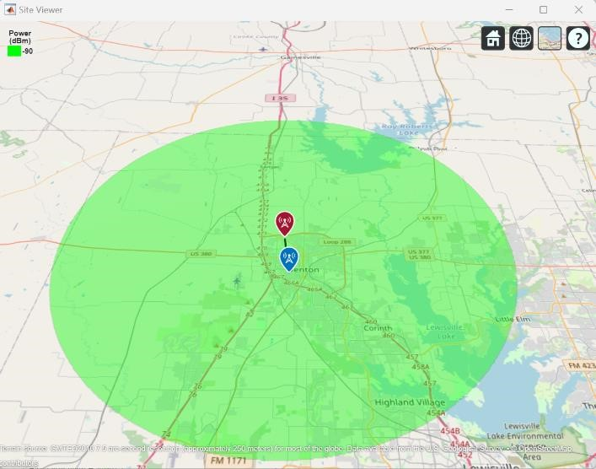
Figure 2 Ideal Coverage Area Visualization of Transmitter

6 Directivity Patterns
Users may design and view the directivity patterns of transmitters utilizing directional antennas by using the Directivity Pattern part in the Swarm Properties panel. By taking into account the antenna's orientation and tilt angle, this function aids in determining the signal coverage and intensity in particular directions.

6.1 Tilt angle and Tilt axis configuration
The directional antenna's tilt angle and tilt axis may be customized by users. The antenna's tilt with respect to the horizontal plane is represented by the tilt angle. The tilt axis, which is commonly described as azimuth (horizontal) or elevation (vertical), designates the axis about which the tilt angle is applied.

6.2 Generating directivity pattern figures
The tilt angle and tilt axis that are supplied are used to determine the directivity pattern of the transmitter. The antenna's radiation pattern is represented by the directivity pattern, which shows how the transmitted signal is dispersed. The signal intensity and coverage at various azimuth and elevation angles are determined by the antenna's properties, such as gain, beamwidth, and radiation efficiency. Graphs are used to depict the computed directivity pattern. A 2D or 3D map of the radiation pattern illustrating how the signal intensity fluctuates with respect to angles is generally included in the display. To depict the signal intensity levels in various directions, the plot may display contour lines or color gradients. For creating the directivity pattern figure, there is need of preparing the yagi-uda antenna for the transmitter frequency. This can be achieved using design() function. Figure 3 gives the glimpse of directivity pattern plot.
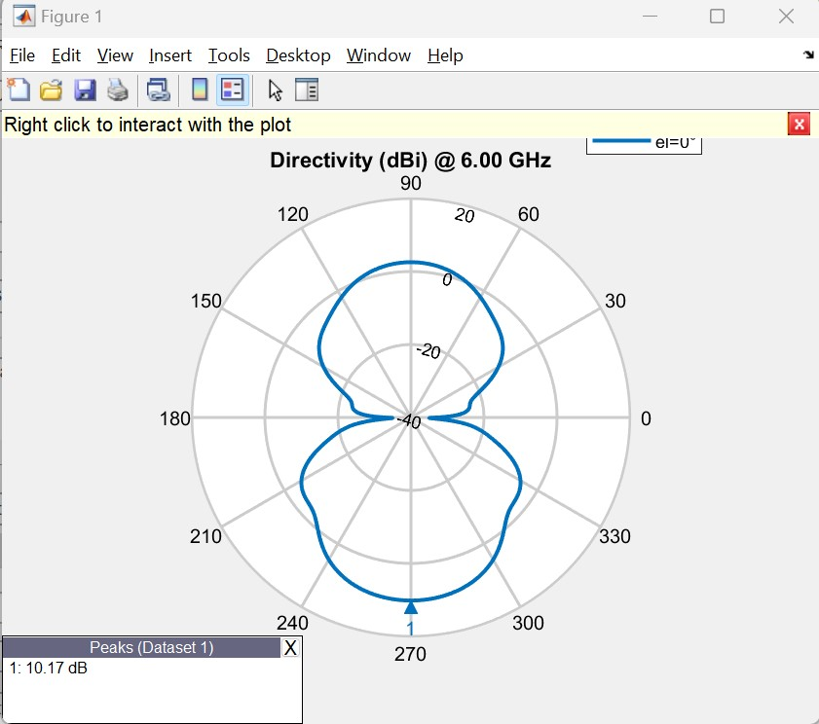
Figure 3 Directivity Pattern
For preparing the directivity pattern figure following matlab functions are utilized,

6.2.1 patternAzimuth()
Plotting the 2-D radiation pattern of an antenna or array object over a given frequency is done using the patternAzimuth(object,frequency,elevation) function. If no value is entered for elevation, zero is used by default. The directivity of the antenna or array object over the chosen frequency will be returned by this function. If no value is entered for elevation, zero is used by default [9].

6.2.1.1 Input Argument

6.2.1.1.1 Object – Antenna
Antenna or array object, specified as a scalar [9].

6.2.1.1.2 Frequency – Frequency used to calculate the charge distribution Frequency used to calculate charge distribution, specified as a scalar in Hz [9].

6.2.1.2 Output

6.2.1.2.1 Directivity – Antenna or array Antenna
Antenna or array directivity, returned as a matrix in dBi. The matrix size is the product of number of elevation values and number of azimuth values [9].

6.3 Visualizing coverage area based on directivity patterns
It is imposed on the transmitter's coverage area based on the directivity array returned by the patternAzimuth() function. The coverage area of the transmitter is also impacted by the directivity pattern. The directivity pattern is taken into consideration when the coverage area is displayed on the map interface to represent the differences in signal strength in various directions. The directivity pattern of the antenna may cause the coverage area to take on erratic forms or fluctuations. The same coverage and connection functions that were previously described were used to create the graphic. Figure 4 shows how the coverage area changes based on the directivity pattern.
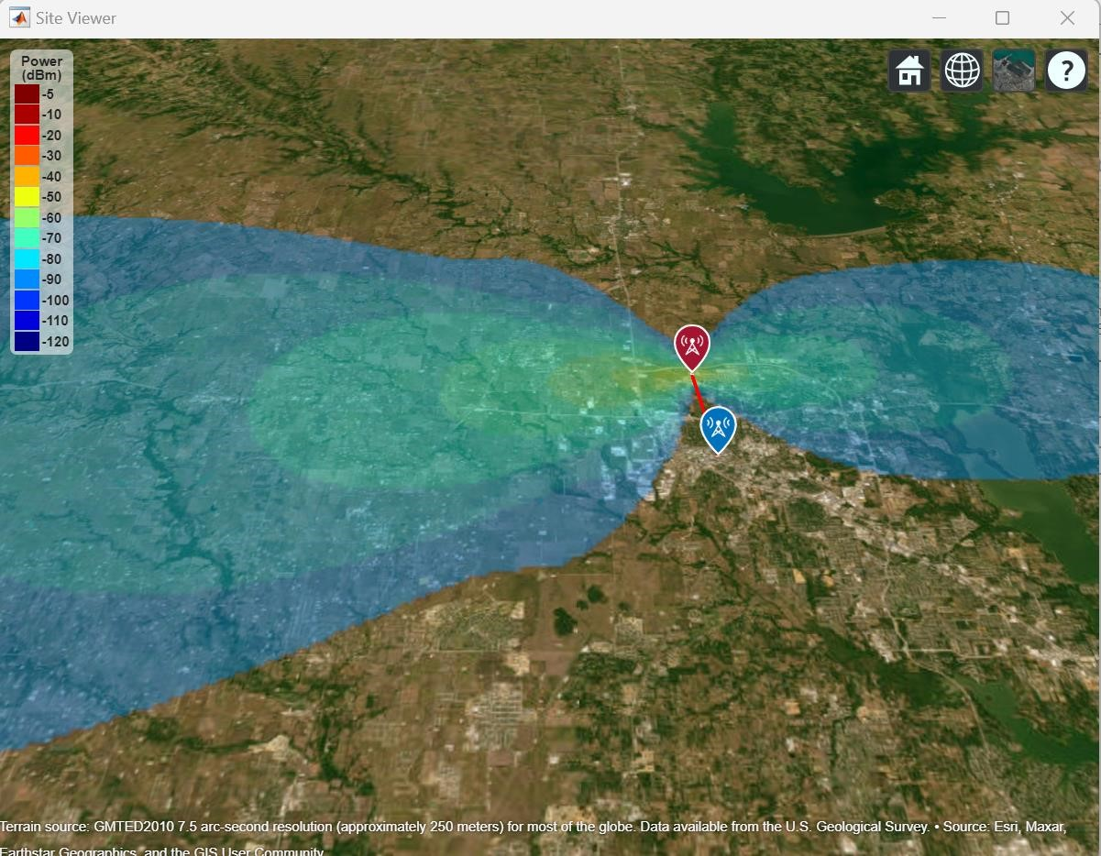
Figure 4 Site Viewer visualization based on Directivity Pattern

7 Signal Map Generation
Users have the choice to produce a dataset for signal transmission and create a heatmap based on particular criteria under the Signal Map Generation page. The method for defining the target area, grid size, distribution type, frequency, and power is described in this paragraph. Additionally, the impediment is taken into account in this area of the code. The characteristic that users enter alongside,.OSM file that was downloaded from the openstreet website is included. When this file is integrated with the siteviewer, which is used to visualize the transmitter's power distribution, concrete buildings are taken into account as signal-blocking obstacles, providing an exact visualization of how the application will operate in a realworld scenario and the locations of the transmission sites.
We use the OpenStreetMap (OSM) platform to include a particular area of interest in the application. On the OSM website, users describe their chosen region and export it as an .osm file. The program then loads this file for additional examination. The siteviewer function receives the name of the corresponding .osm file as an input when the coverage function is used to visualize the coverage area. The siteviewer automatically combines the buildings from the OSM data as barriers while taking into mind the defined region. Given the existence of impediments in the target area, this enables a more accurate portrayal of the coverage area.

7.1 Dataset Generation

7.1.1 Specifying target region, grid size, distribution type, frequency, and power

7.1.1.1 Target Region
Users define the target area by entering the north-east and south-west corner coordinates.
The geographic region of interest for signal transmission analysis and heatmap production is defined by these coordinates.
Additionally, the user has the option to define how many transmitters they want in the provided target area. For the time being, the application was prepared for either one or two transmitters at a certain assessment instance.

7.1.1.2 Grid Size
Users can choose the grid size to divide the target area into smaller cells, with the centroid of each cell serving as the cell's representative mainstream coordinate.
The precision and granularity of the dataset and generated heatmap are determined by the grid size.
The overall number of individual sites for signal transmission analysis depends on the grid's number of rows (n) and columns (m).

7.1.1.3 Distribution Type
Users can choose the distribution type used to create random locations inside each grid cell.
The geographic distribution of the transmitter locations inside each grid cell is determined by the distribution type.
The currently available distribution type is linear, which creates random locations in each grid cell according to a linear distribution.

7.1.1.4 Frequency
Users specify the frequency at which the transmitters operate.
The frequency affects the propagation characteristics and signal behavior in the environment.

7.1.1.5 Power
Users define the power level of the transmitters.
The power level indicates the strength of the transmitted signal and influences the signal coverage and strength.

7.1.2 Generating random sites
The "Generate Random Sites" button is clicked by users to start the generating process.
Within each grid cell of the target zone, the program creates transmitter sites using the parameters that have been supplied. The transmitter sites' coordinates are based on the centroid of each. The signal strength for each cell's centroid is calculated using the signalStrength() method. It is anticipated that the cell's centroid will get the same amount of electricity as the rest of the cell.

7.1.2.1 signalStrength()
This function returns the signal strength in power units (dBm) at the receiver site due to the transmitter site [10].

7.1.2.1.1 Input Argument

7.1.2.1.1.1 rx – Receiver Sites
The rxsite() function object, which represents the receivers' sites, is expected as an argument. Additionally, an array of receiver site objects can be supplied as an argument if several receivers need to be passed [10].

7.1.2.1.1.2 tx – Transmitter Sites:
The txsite() function object, which denotes the transmitter locations, is expected as a parameter. Using an array technology, many transmitter locations may be provided. An array can include several txsite objects, and that array can be provided as a parameter [10].

7.1.2.1.1.3 propmodel – Propagation model to use for path loss calculation Propagation model to use for the path loss calculations [10].

7.1.2.1.2 Output

7.1.2.1.2.1 ss – Signal Strength
Signal strength, returned as M-by-N array, where M is the number of transmitter sites and N is the number of receiver sites [10].

7.2 Site Visualization
Users have the choice to produce a dataset for signal transmission and create a heatmap based on particular criteria under the Signal Map Generation page. The method for defining the target area, grid size, distribution type, frequency, and power is described in this paragraph.

7.2.1 Coverage area visualization
The depiction of the coverage area gives information about the breadth and depth of signal coverage for each transmitter location. The coverage function in MATLAB, which makes use of the raytracing propagation model, is used to carry out this visualization. By selecting the "Visualize Coverage Area" option, the chosen transmitter site's coverage area is calculated and shown on the map. The coverage area utilizes the raytracing propagation model and takes into account obstructions like buildings to calculate the signal reach. On the map interface, the coverage area is shown as a highlighted area or as a color gradient. An intuitive comprehension of the signal propagation range is provided by the visual depiction, which shows the size of the coverage region.
Users may assess the signal coverage of each transmitter site using the coverage area visualization, and they can also see places where the signal might be weaker or stronger. The location of transmitters and receivers may be improved with the use of this information, resulting in efficient signal transmission and reception throughout the target area.
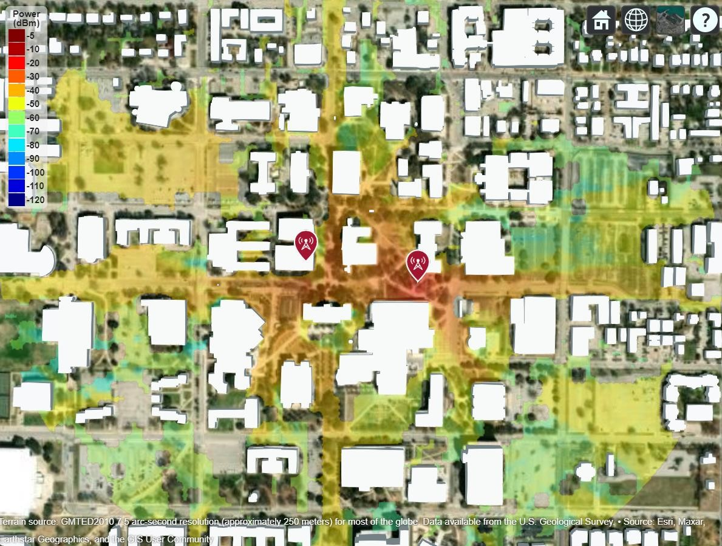
Figure 5 Site Viewer for Coverage Area of random generated sites

7.2.2 Heatmap generation
Based on the grid, heat map visualization offers a thorough picture of the signal intensity distribution over the target region. The signalStrength() method in the program uses the grid cells and transmitter locations to determine the signal strength for each cell. The signal intensity distribution over the target region is shown on the heat map that was created. Different colors denote differing signal levels, and the signal strength values are represented using a color gradient or color coding.
The heat map may be visually analyzed by users to show locations with better or worse signal coverage. Strong coverage is shown by greater signal strength, whereas possible signal weak places are indicated by lower signal strength. Users can locate areas where environmental variables or barriers may impact signal strength by looking at the heat map.
Users may acquire a thorough grasp of the signal distribution throughout the target region by using the heat map display. It helps in determining regions where more transmitters or signal amplification methods might be necessary to provide reliable signal coverage.
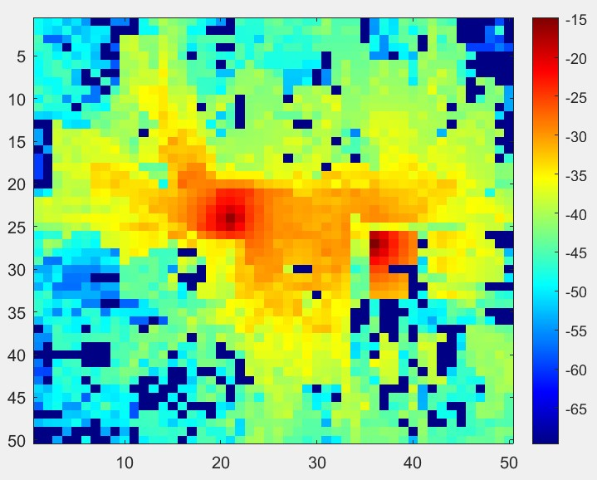
Figure 6 Heat Map for randomly generated site

7.3 Dataset Export
The data export functionality in the application allows users to save and download important data related to the signal propagation and coverage analysis.

8 Conclusion

8.1 Summary of the project's features and capabilities
RF Propagation & Trajectory Studio provides a comprehensive suite of tools for wireless coverage analysis, trajectory simulation, and dataset generation. Key capabilities include:

8.1.1 Environmental Properties Panel:
Enables users to define the target area by giving the area's north, east, and south-west coordinates.
Offers a variety of propagation models (such as rain, fog, and freespace) to mimic various environmental circumstances.
Provides a choice of basemap options for displaying the target area.

8.1.2 Map Panel: highlights the selected area on a map of the target region. allows users to adjust the map representation by selecting a basemap from a dropdown menu.

8.1.3 Swarm Properties Panel: allows users to specify the locations of the transmitter and receiver. supports manually entering site information or uploading a CSV file with the necessary data. highlights the locations on the map and visualizes the coverage area to provide visual feedback.
enables the use of directional antennas to create and view directivity patterns.

8.1.4 Signal Map Generation Panel:
creates datasets more easily for signal transmission analysis. enables users to define the transmitter frequency, power, distribution type, target region, and grid size. facilitates site visualization by generating random transmitter locations based on the chosen grid.
visualizes the coverage regions depending on the transmitters, taking into account impediments like buildings.
creates heat maps that show how the signal intensity is distributed throughout the target area.

8.1.5 Data Export:
Data export allows users to designate a download location for power distribution and heat map data. provides easy choices for organizing and exporting the data for additional study.
A complete toolset for signal propagation analysis is provided by the program, which incorporates a variety of capabilities. Users may specify the target area, simulate various environmental factors, view transmitter and receiver locations, create coverage maps, and export the outcomes for more investigation. With the help of this feature set, users may plan wireless networks, improve signal coverage, and choose antennas with knowledge. They can also obtain insights into the peculiarities of signal propagation.

8.2 Future enhancements and possibilities
While the application already provides a rich feature set, several enhancements are planned for future releases:

8.2.1 Advanced Visualization Options:
By utilizing 3D visualization approaches, improve the visualization ability. Users will be able to comprehend signal coverage and interference in intricate spatial contexts better as a result.

8.2.2 Machine Learning Integration:
Investigate the use of machine learning algorithms to automate processes including determining the best locations for transmitters and receivers based on predetermined goals, estimating signal coverage, and selecting the best antenna designs.

8.2.3 Real-time Data Acquisition:
Add real-time data collecting tools to gather and examine data on current signal transmission. As a result, users would be able to conduct analyses immediately and make dynamic modifications in response to shifting environmental conditions.

8.2.4 Integration with Geographic Information Systems (GIS):
Integrate the app with well-known GIS platforms to take use of their geographical analytic tools, gain access to more geographic datasets, and enable frictionless data transfer between the app and external GIS systems.
By taking into account these potential upgrades and developments, the created MATLAB application can develop into a strong and adaptable tool for signal propagation analysis, serving a wider range of users' needs and fostering cutting-edge study and research in wireless communications and antenna design.

9 Trajectory Generation & Simulation
The Synthetic Trajectory Generator tab provides tools for creating, visualizing, and simulating mobile trajectories within a geographic region. It supports two generation approaches: transformer-based synthesis from road-network data, and RRT-based obstacle-aware path planning with configurable antenna angle modes.

9.1 Transformer-Based Trajectory Generation
This approach uses a pre-trained transformer model to generate synthetic trajectories that follow learned road-network movement patterns. It requires the word2vec-master_new Python package to be installed locally.

9.1.1 Visualize Network Nodes
Click Visualize Network Nodes to display all available road-network nodes on a geographic plot. The app reads node coordinates from word2vec-master_new/data/rome/road/node.csv and plots each node as a dot. Hover over any node to view its Node ID, latitude, and longitude. Use these Node IDs as seed inputs for trajectory generation.

9.1.2 Single Seed Generation
Enter one or more comma-separated node IDs (e.g., 1234,5678,9012) in the Seed Trajectory field, then click Generate Trajectory. The app invokes the Python script eval.py with these seeds. The transformer model predicts a plausible continuation of the node sequence, producing a synthetic trajectory saved as a .mat file.

9.1.3 Batch Generation
Click Upload .mat File to load a matrix of seed sequences (one row per trajectory). The app iterates over each row and calls the same Python pipeline, generating multiple synthetic trajectories in a single batch operation.

9.2 RRT-Based Path Planning
This approach generates obstacle-aware trajectories using Rapidly-exploring Random Tree (RRT) path planning. The app downloads OpenStreetMap building data for the specified region, builds a 256x256 binary occupancy grid, and plans collision-free paths. Each trajectory is sampled to 100 waypoints in geographic coordinates.

Configuration parameters:
NW Latitude / NW Longitude — northwest corner of the target region.
Number of Trajectories — how many paths to generate.
Building Avoidance — obstacle inflation radius (in grid cells). Higher values keep trajectories farther from buildings.

9.2.1 Antenna Angle Modes
Each trajectory point carries an antenna orientation angle. Three modes control how angles are assigned:

Random Angle — Each waypoint receives a random antenna angle between 0° and 360°. Click the Random angle button to generate trajectories in this mode.
Fix Angle — A stationary target is randomly placed in the free space. At each waypoint, the antenna angle is computed as the geographic bearing toward that target, simulating a mobile transmitter tracking a fixed receiver. A random beamwidth (6–20°) is assigned per trajectory. Click the Fix angle button to use this mode.
Pairwise Target — Requires at least two existing trajectories. The selected trajectory (A) is paired with the next one (B). At each point of A, the angle points toward the nearest point on B, simulating two mobile agents tracking each other. Click the Pairwise Target button to use this mode.

9.3 Trajectory Management
All generated trajectories are stored internally and listed in the Select Trajectory dropdown. The following actions are available:

Visualize Trajectory — Plots the active trajectory on the map. If the trajectory has an associated target (Fix Angle mode), a red dot marks the target location.
Save Trajectory — Exports the active trajectory as a CSV file with latitude and longitude columns. If angle and target data exist, a second file (*_targetAndAngles.csv) is saved alongside.
Save All — Exports every loaded trajectory to a chosen directory as trajectory_1.csv, trajectory_2.csv, etc.
Visualize A-B and A1 Angle — Overlays trajectories A and B on the map with the recomputed pairwise angle vectors for verification.

9.4 Signal Simulation Along Trajectories
This feature treats each trajectory waypoint as a transmitter and computes a signal strength map at receiver sample points across the region.

Simulation parameters:
• Carrier frequency: 28 GHz
• Transmitter power: 1 W
• Antenna height: 2 m
• Antenna: 8×8 Uniform Rectangular Array (URA) with Gaussian elements
• Propagation model: Ray-tracing (SBR), 1 reflection, 0 diffractions
• Antenna angle and beamwidth: taken from the trajectory properties

Workflow:
1. The app loads OSM building data and creates a site viewer.
2. One txsite is created per trajectory waypoint, each configured with the stored angle and beamwidth.
3. Receiver positions are sampled using coverage_test() to account for building geometry, then filtered to the 256 m bounding box.
4. sigstrength() computes the received power at every sample point for each transmitter.
5. Results are exported as Excel files (one per waypoint) to the output directory (e.g., synctest_trajectoryDataset1/).

Simulate All repeats this for every loaded trajectory, writing to sequentially numbered directories (trajectoryDataset1/, trajectoryDataset2/, etc.). This is designed for generating trajectory-indexed signal-map datasets at scale.

9.5 Vehicle Kinematics Comparison
The Vehicle Variation tab simulates how different mobile-robot kinematic models follow the active trajectory. Select one or more models from the checkbox tree:

Unicycle — Point-robot model with direct linear and angular velocity inputs. Simple and fast; suitable for basic motion analysis.
Bicycle — Front-steered vehicle with a maximum steering angle of π/8 rad. Produces smoother, more realistic cornering behavior.
Differential Drive — Two-wheeled robot with independent wheel speed control (range: ±10×2π rad/s). Can turn in place.

All models use Pure Pursuit path following (linear velocity 3 m/s, max angular velocity 3π rad/s). Geographic coordinates are converted to UTM for simulation, then back for map overlay. Each model's resulting path is plotted alongside the reference trajectory for comparison.

9.6 Region-Based Dataset Generation
The Generate button launches automated signal-map dataset creation for a specified region:

1. Enter the NW Latitude and NW Longitude to define a 256 m × 256 m region.
2. Click Generate and enter the desired number of transmitters in the dialog.
3. The app downloads OSM building data, identifies valid (non-building) receiver positions, and randomly places transmitters at valid locations.
4. Each transmitter is configured with an 8×8 Gaussian URA antenna at a random orientation.
5. Signal strength is computed using ray-tracing (SBR, 1 reflection) and exported as Excel files. A transmitter_coordinates.xlsx index file is also generated.

A progress bar on the button tracks completion during generation.

9.7 Dependencies & Notes
• coverage_test and coverage256timed — building-aware coverage sampling helpers (included in repo).
• trajectory.m — trajectory data class used to store waypoints, angles, targets, and beamwidth.
• Python + word2vec-master_new — required only for transformer-based trajectory generation (Section 9.1).
• OSM data is fetched automatically via the OpenStreetMap API using curl.

10 References
Create geographic axes. (n.d.-a). MATLAB Geoaxes. Retrieved June 30, 2023, from https://www.mathworks.com/help/matlab/ref/geoaxes.html
Plot line in geographic coordinates. (n.d.). MATLAB Geoplot. Retrieved June 30, 2023, from https://www.mathworks.com/help/matlab/ref/geoplot.html
Set or query basemap. (n.d.). MATLAB Geobasemap. Retrieved June 30, 2023, from https://www.mathworks.com/help/matlab/ref/geobasemap.html
Create RF propagation model. (n.d.). MATLAB propagationModel. Retrieved June 30, 2023, from https://www.mathworks.com/help/antenna/ref/propagationmodel.html
Create RF transmitter site. (n.d.). MATLAB. Retrieved June 30, 2023, from https://www.mathworks.com/help/antenna/ref/txsite.html
Create RF transmitter site. (n.d.). MATLAB. Retrieved June 30, 2023, from https://www.mathworks.com/help/antenna/ref/rxsite.html
Display or compute coverage map. (n.d.). MATLAB Coverage. Retrieved June 30, 2023, from https://www.mathworks.com/help/antenna/ref/txsite.coverage.html
Display or compute coverage map. (n.d.). MATLAB Coverage. Retrieved June 30, 2023, from https://www.mathworks.com/help/antenna/ref/rxsite.link.html
Azimuth pattern of antenna or array. (n.d.). MATLAB patternAzimuth. Retrieved June 30, 2023, from https://www.mathworks.com/help/antenna/ref/patternazimuth.html
Received signal strength. (n.d.). MATLAB Sigstrength. Retrieved June 30, 2023, from https://www.mathworks.com/help/antenna/ref/rxsite.sigstrength.html

Basemaps |  | Description
Streets-light |  | Map that highlights user data on a white backdrop while providing geographic context.
Streets-dark |  | An interactive map that highlights user data on a dark background while providing geographic context.
Streets |  | a general-purpose road map that places an emphasis on the precise, readable style of highways and transportation systems.
Satellite |  | a whole world basemap made from high-resolution satellite images.
Topographic |  | a general-purpose map with topographic feature style.
Landcover |  | a map with shaded relief, ocean bottom relief, and land cover data taken from satellites. The natural, light color scheme works well for both reference and themed maps.
Colorterrain |  | Combining a land cover palette with a shaded relief map. Dry lowlands are brown, whereas humid lowlands are green.
Grayterrain |  | Grayscale map of the terrain. Lowland micro-terrain and towering mountains are both highlighted by shaded relief.
Bluegreen |  | Light green land regions and light blue sea areas are shown on this two-tone, landocean map.
Grayland |  | a two-tone, land-ocean map featuring regions of white water and gray land.
Darkwater |  | Two-tone globe map with light gray land and dark gray ocean. This basemap is installed with MATLAB.
Propagation Model |  | Description
Freespace |  | Free space propagation models have no enforced frequency range, assume lineof-sight (LOS) conditions, and disregard terrain, the curvature of the Earth, and other obstacles [4].
Rain |  | Propagation models for rain are valid from 1 to 1000 GHz, assume line-of-sight (LOS) conditions, and disregard terrain, the curvature of the Earth, and other obstacles [4].
Gas |  | Propagation models for gas are valid from 1 to 1000 GHz, assume line-of-sight (LOS) conditions, and disregard terrain, the curvature of the Earth, and other obstacles [4].
Fog |  | Propagation models for fog are valid from 10 to 1000 GHz, assume line-of-sight (LOS) conditions, and disregard terrain, the curvature of the Earth, and other obstacles [4].
Close-in |  | Model the behavior of electromagnetic radiation from a point of transmission as it travels through urban macro cell scenario [4].
Longley-rice |  | Model the behavior of electromagnetic radiation from a point of transmission over irregular terrain, including buildings, by using the Longley-Rice model, also known at the Irregular Terrain Model (ITM) [4].
Raytracing |  | RayTracing objects are propagation models that compute propagation paths using 3-D environment geometry [4].
Attribute |  | Description
Name of Site |  | This attribute takes the name of the site as an input. It will take string value an input.
Latitude |  | This field takes latitude ordinate of the site’s coordinate. It will take float value as an input.
Longitude |  | This field, which takes float value as an input, takes longitude ordinate of the coordinate.
Frequency |  | This field is takes positive integer number, which further gets multiplied by 109, which will act as the frequency of the transmitter. Units of the frequency is set to be in Hertz (Hz).
Antenna Height |  | This field takes positive integer as an input, which will serve as the antenna height of the transmitter. By default, unit for this field is set to be in meters
Transmitter Power |  | This field treat the positive integer input as the transmitter power, where by default units will be Watts.
Attributes |  | Description
Name of Site |  | This attribute takes the name of the site as an input. It will take string value an input.
Latitude |  | This field takes latitude ordinate of the site’s coordinate. It will take float value as an input.
Longitude |  | This field, which takes float value as an input, takes longitude ordinate of the coordinate.
Receiver Sensitivity |  | This field takes the numeric scalar which defines the minimum received power to detect the signal, specified as a numeric scalar or a row vector in dBm.
Attributes | Description | Active/NonActive for Transmitter (0/1) | Active/Non active for Receiver
SiteType | Transmitter - 0 /  Receiver - 1 | 1 | 1
Name | Name of the Site | 1 | 1
Latitude | Geo Latitude of the  site | 1 | 1
Longitude | Geo Longitude of the  site | 1 | 1
CoordinateSystem | geographic (default) | cartesian | 1 | 1
TransmitterAntenna | isotropic | monopole | dipole | 1 | 0
TransmitterAntennaAngle | 0 (default) about xaxis | numeric scalar | 1 | 0
TransmitterAntennaHeight | 10 (default) | nonnegative numeric scalar | 1 | 0
TransmitterAntennaPosition | [0;0;0] (default | 3 by-  1 vector | 1 | 0
TransmitterSystemLoss | 0 (default) |  nonnegative scalar | 1 | 0
TransmitterFrequency | 1.9e+09 (default) |  positive scalar | 1 | 0
TransmitterPower | 10 (default) | positive scalar | 1 | 0
ReceiverAntenna | isotropic | monopole | dipole | 0 | 1
ReceiverAntennaAngle | 0 (default) about xaxis | numeric scalar | 0 | 1
ReceiverAntennaHeight | 10 (default) | nonnegative numeric scalar | 0 | 1
ReceiverAntennaPosition | [0;0;0] (default | 3 by-  1 vector | 0 | 1
ReceiverSystemLoss | 0 (default) |  nonnegative scalar | 0 | 1
ReceiverSensitivity | negative 100  (default) | numeric  scalar | 0 | 1

